Table of Contents

SwiftCompare 2

FourierRocks 4

AudioGrabber 6

FolderSynch 7

Audio DiffMaker 8

Zynamics BinDiff 10

BinDiff 12

Image Compare 13

Bolide Audio Comparer 14

Bolide Image Comparer 15

Bolide Compare Suite 16

WinMerge 18

QuickDiff 20

PrestoSoft ExamDiff 21

KaleidoScope 25

Docu-Proof Enterprise 29

WorkShare Compare 30

SoftInterface Diff Doc 32

Araxis Merge 33

BitBQ Changes 36

Devart Code Compare 37

Compare++ 39

Sourcegear DiffMerge 41

Pretty Diff 43

Kompare 44

Ultra Compare 45

Code Difference Comparison Tool 49

Diffuse 50

Compare&Merge 51

Formula Software 52

ColorDiffs 54

Compare PDF 55

DiffPDF 57

Meld 58

## SwiftCompare

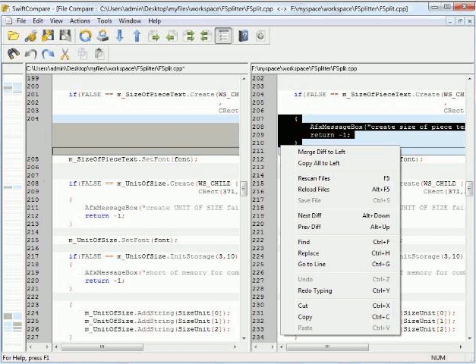

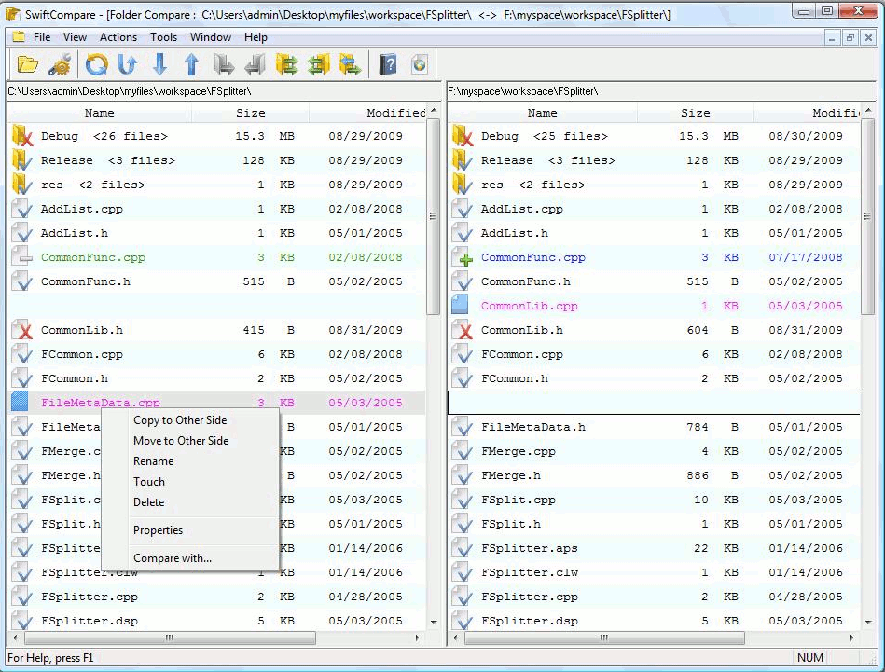

<http://www.oorjasoftware.com/product_info.html>

<http://swiftcompare.software.informer.com/>

## FourierRocks

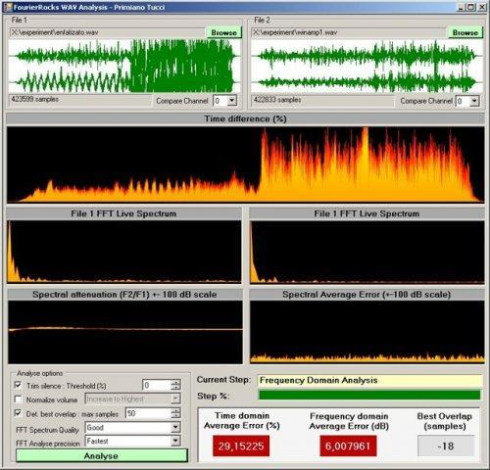

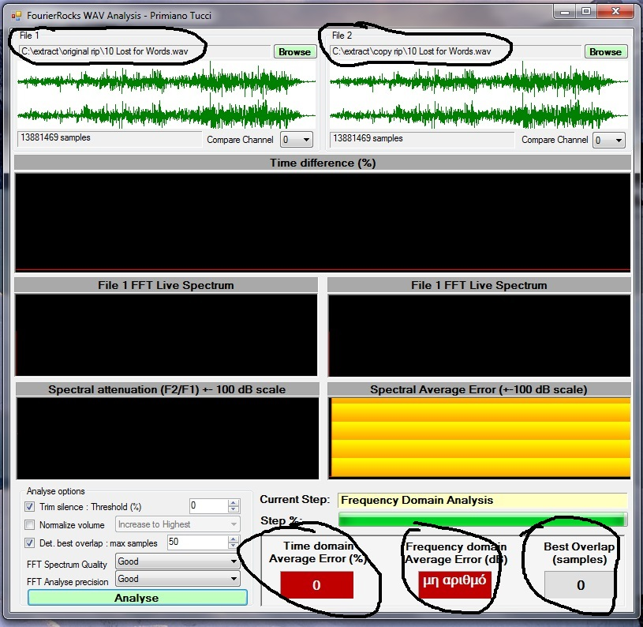

<http://sourceforge.net/projects/fourierrocks/>

<http://www.aca.gr/index/hiend/hiendArticles?row=2063>

## AudioGrabber

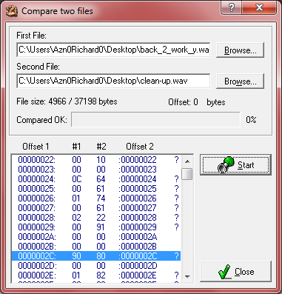

<http://www.audiograbber.org/>

## FolderSynch

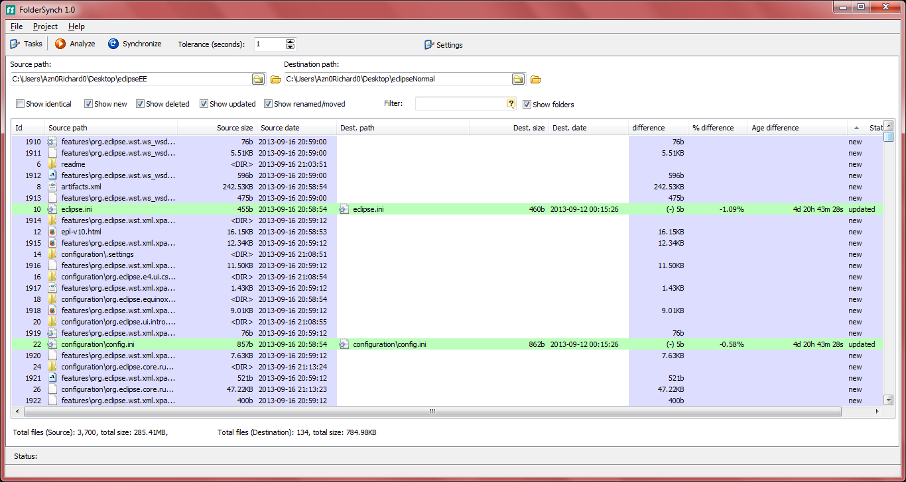

Uses winmerge/FilePro for comparisons

<http://saleensoftware.com/FolderSync>

## Audio DiffMaker

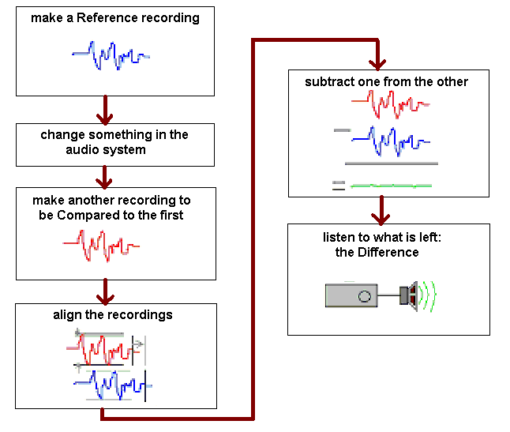

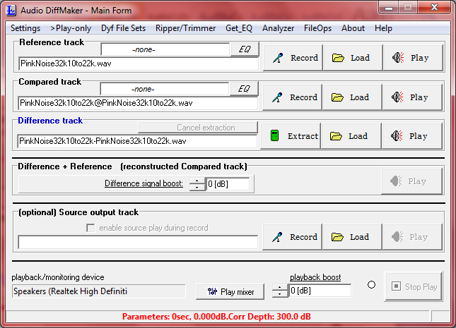

<http://www.libinst.com/Audio%20DiffMaker.htm>

## Zynamics BinDiff

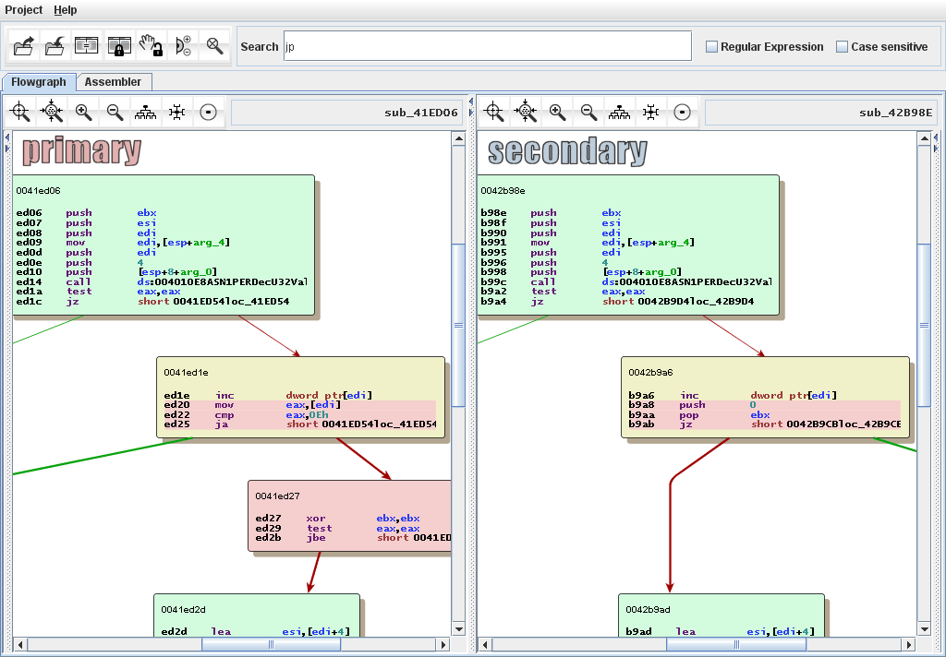Changes in yellow new in red

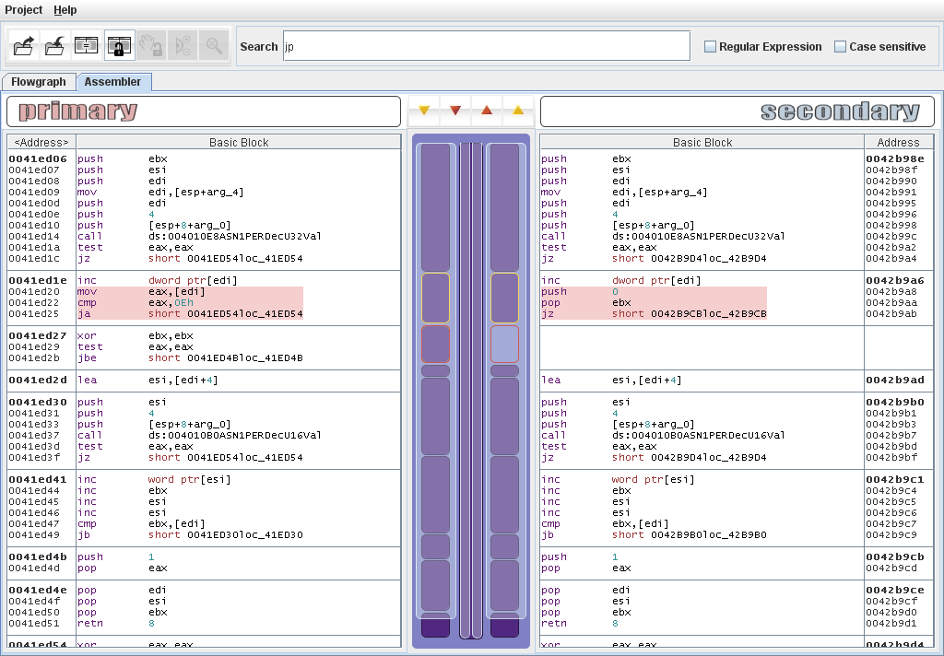

<http://www.zynamics.com/bindiff.html>

## BinDiff

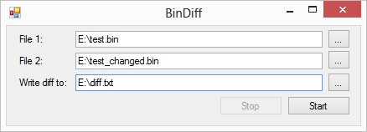

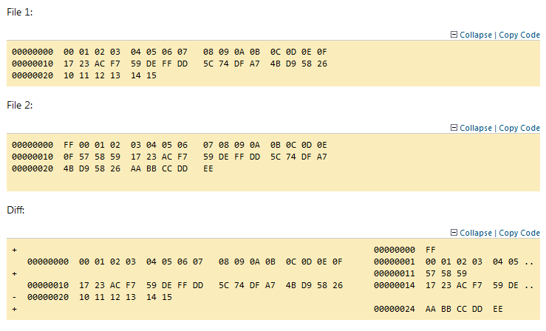

<http://www.codeproject.com/Articles/509425/BinDiff-A-tool-to-compare-binary-files>

## Image Compare

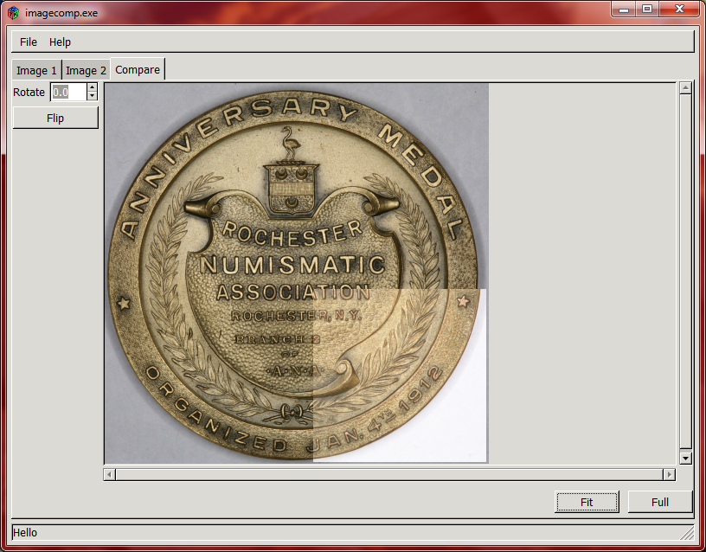

<http://sourceforge.net/projects/imagecomp/>

## Bolide Audio Comparer

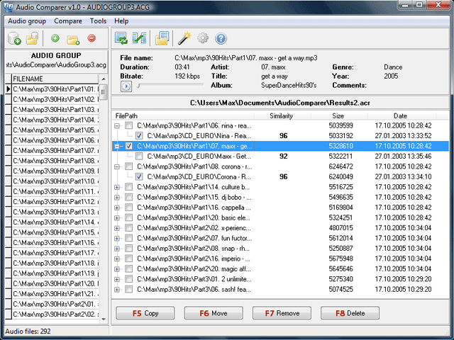

<http://www.bolidesoft.com/audiocomparer/>

## Bolide Image Comparer

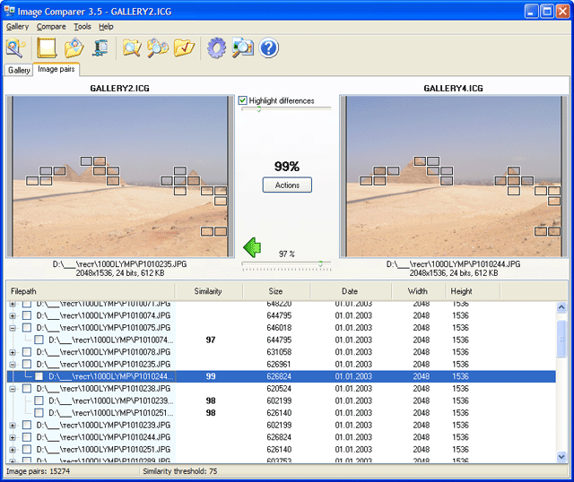

<http://www.bolidesoft.com/imagecomparer.html>

## Bolide Compare Suite

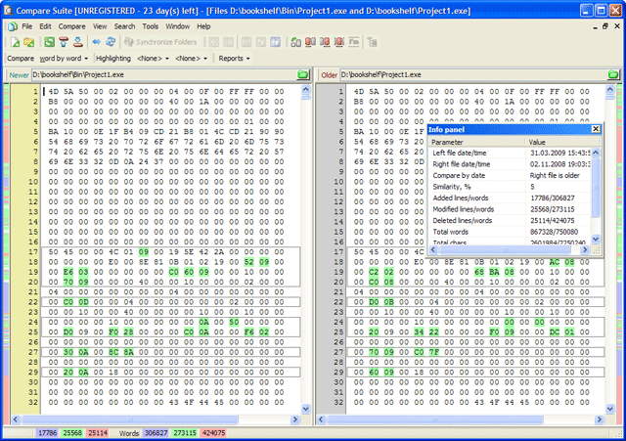

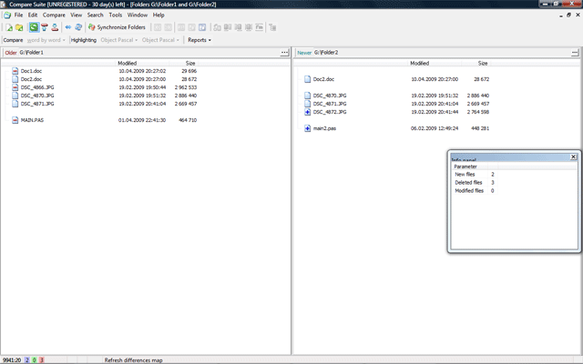

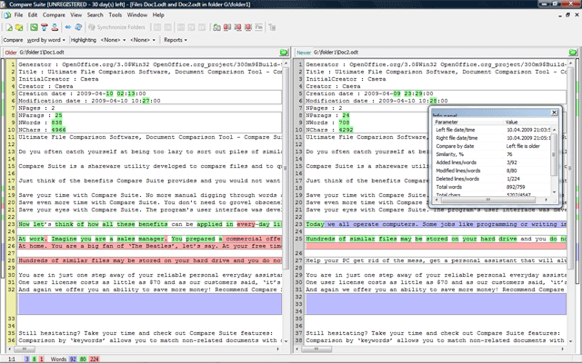

http://www.bolidesoft.com/compare-suite/screenshots.html

## WinMerge

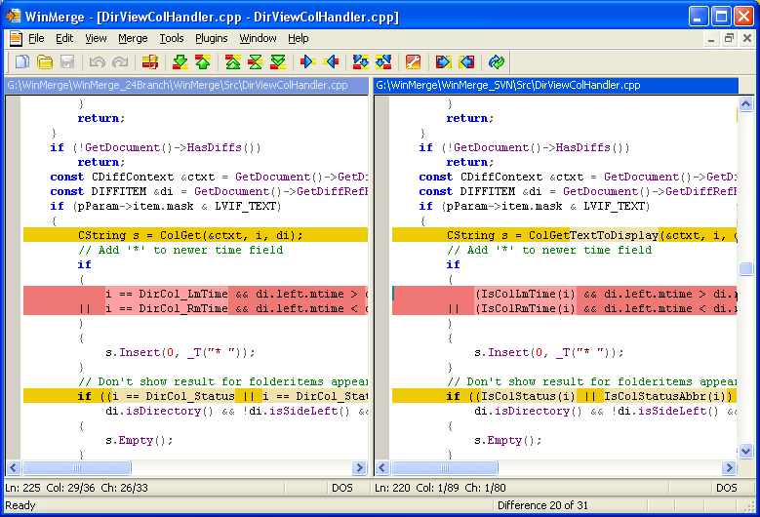

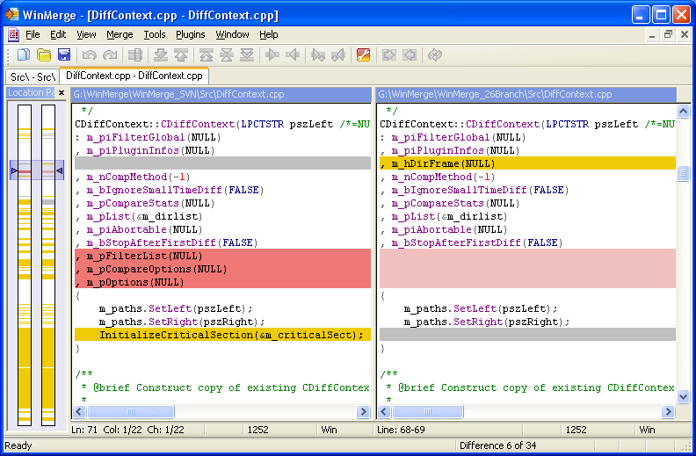

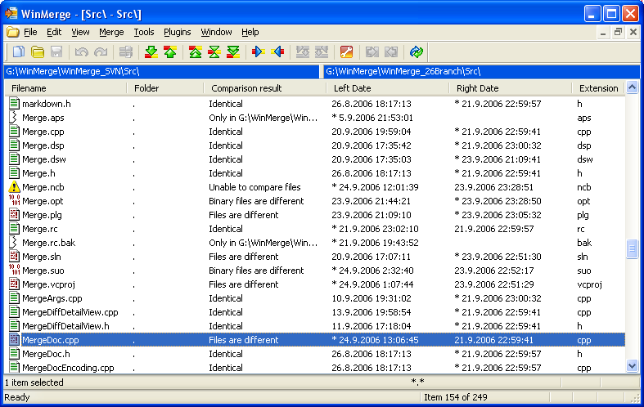

<http://winmerge.org/>

## QuickDiff

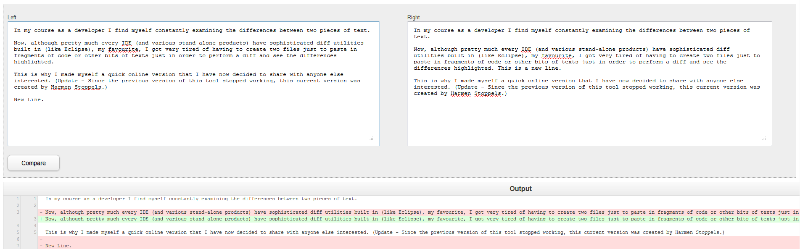

Online diff tool

http://www.quickdiff.com/

## PrestoSoft ExamDiff

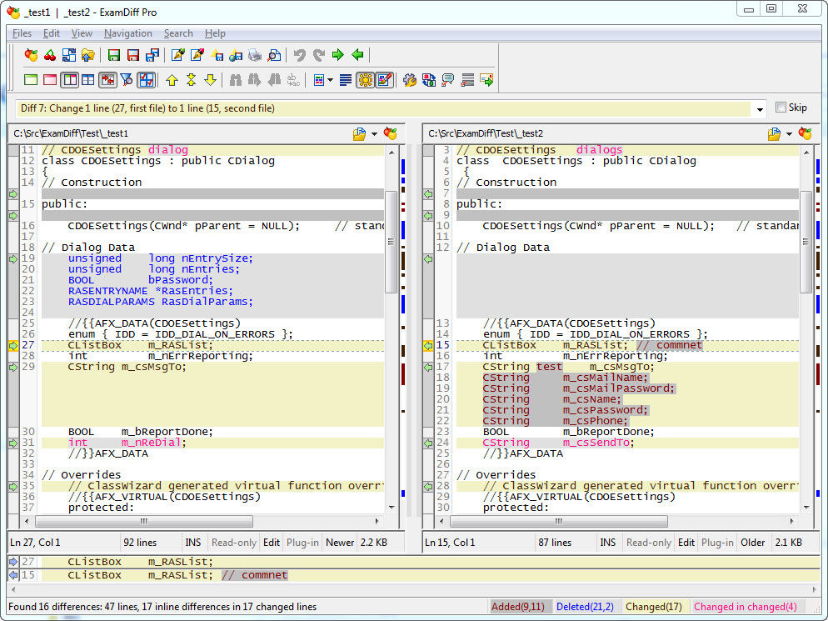

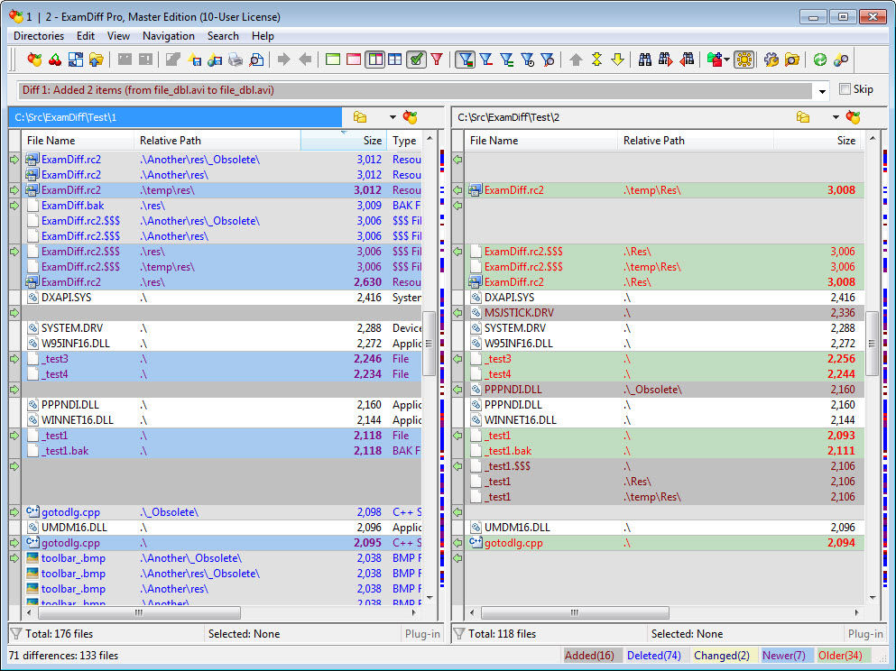

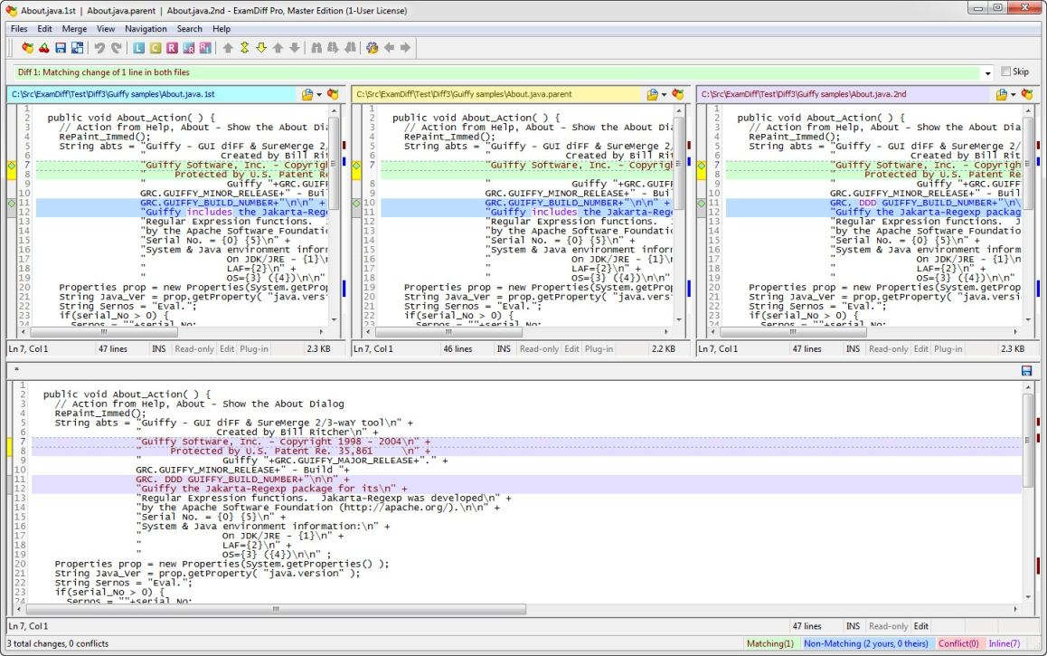

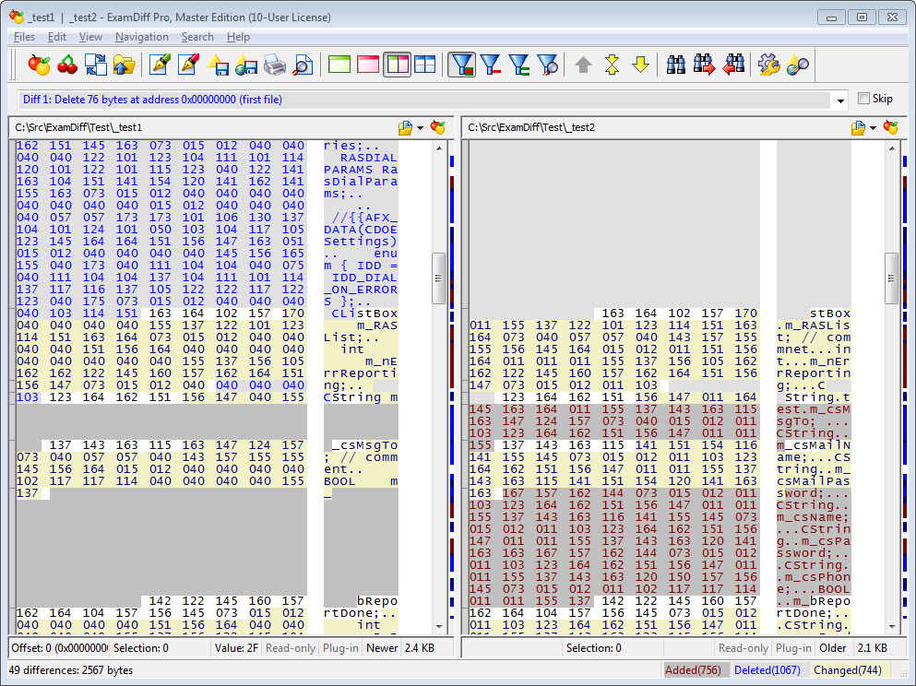

http://www.prestosoft.com/edp_examdiffpro.asp

## KaleidoScope

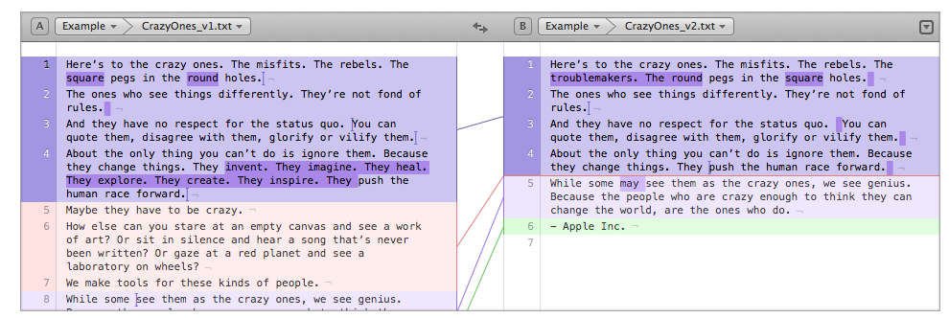



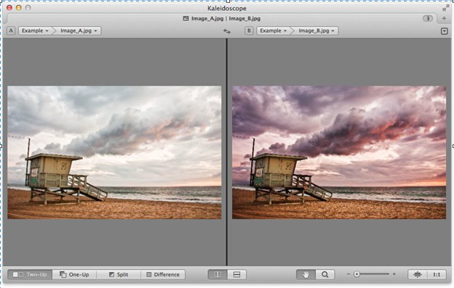

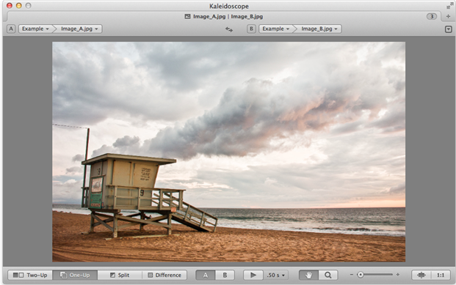

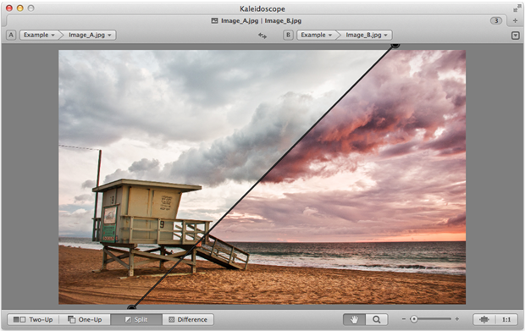

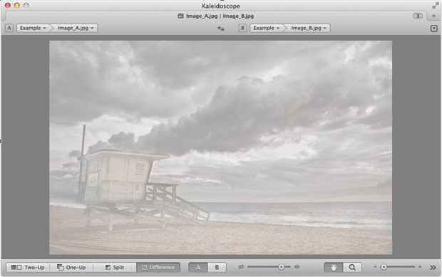

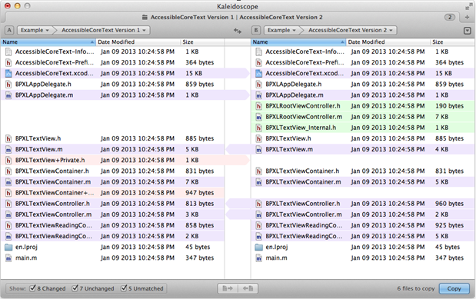

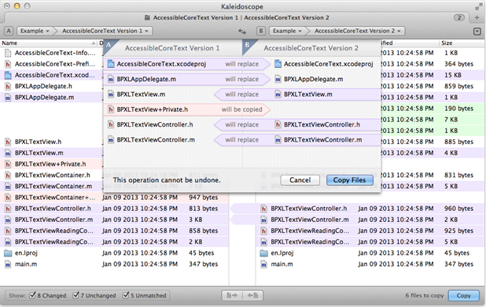

<http://www.kaleidoscopeapp.com/>

## Docu-Proof Enterprise

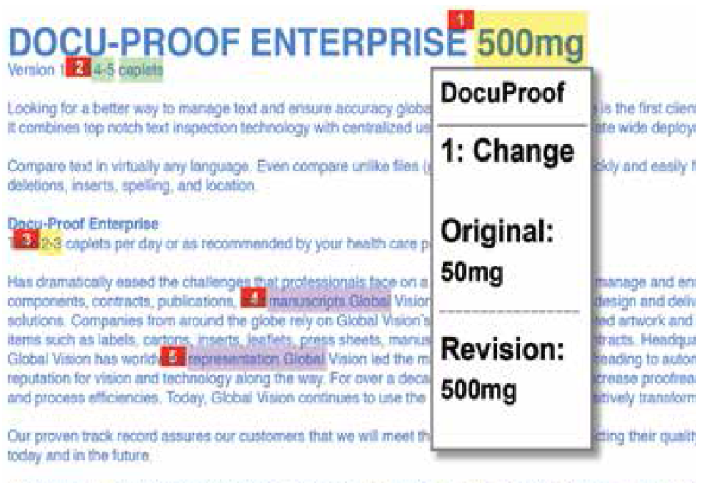

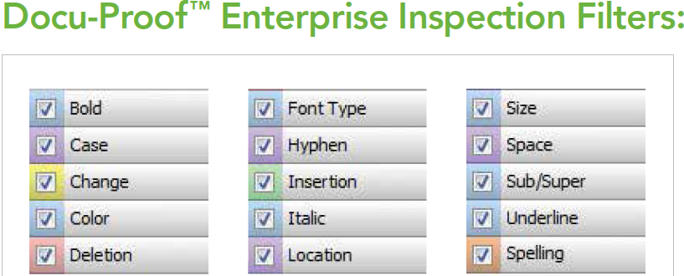

<http://www.globalvisioninc.com/products/docuproof.php>

## WorkShare Compare

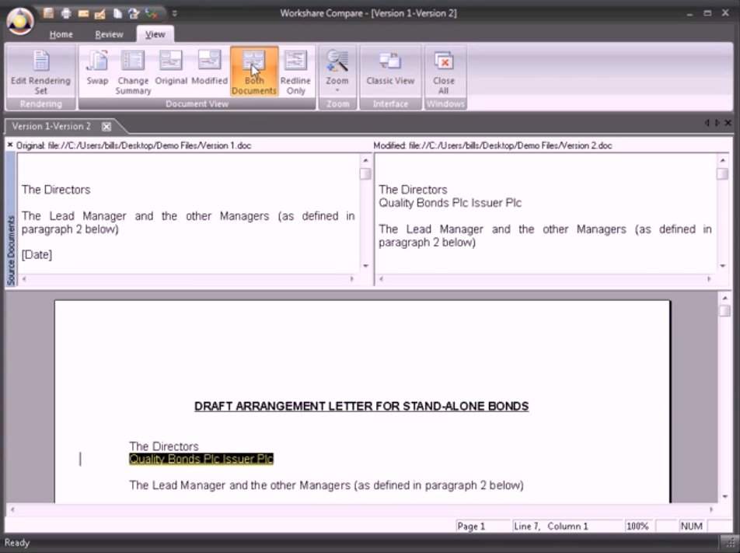



<http://www.workshare.com/products>

## SoftInterface Diff Doc

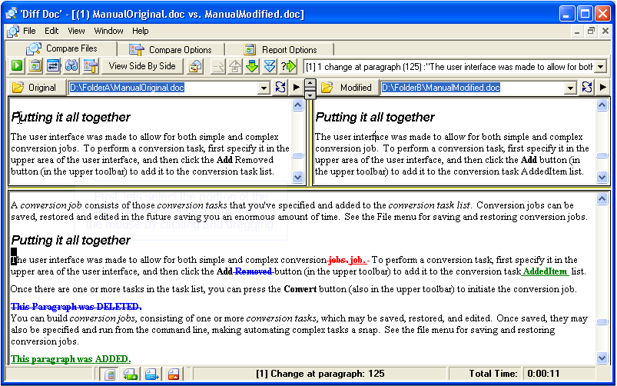

<http://www.softinterface.com/MD%5CDocument-Comparison-Software.htm>

## Araxis Merge

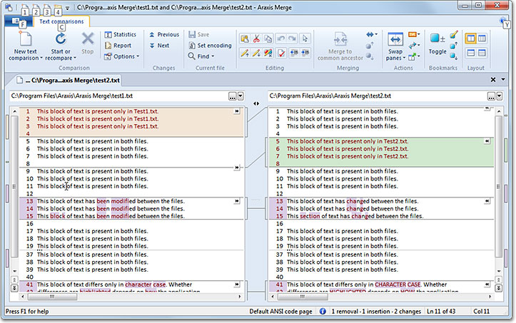

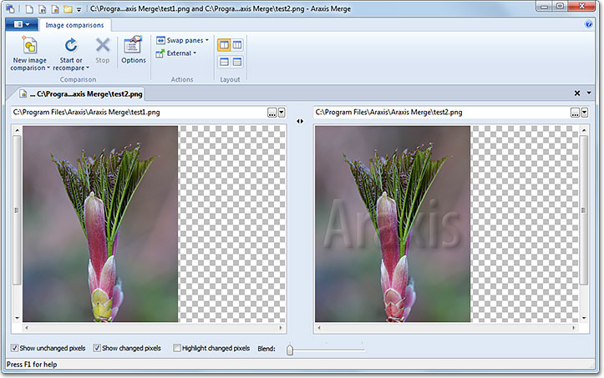

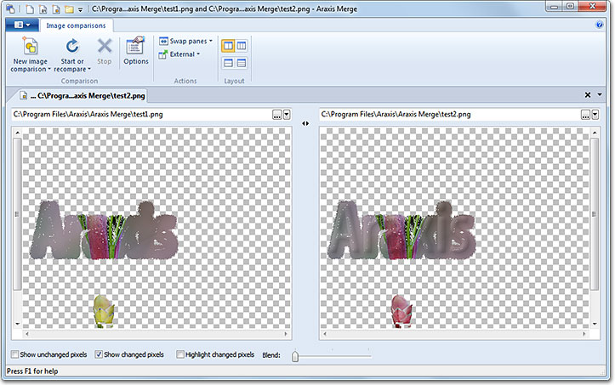

Shows only the pixels that are different between the two files.

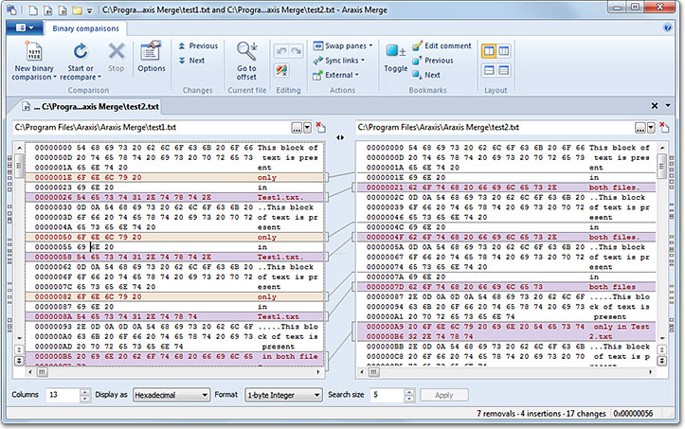

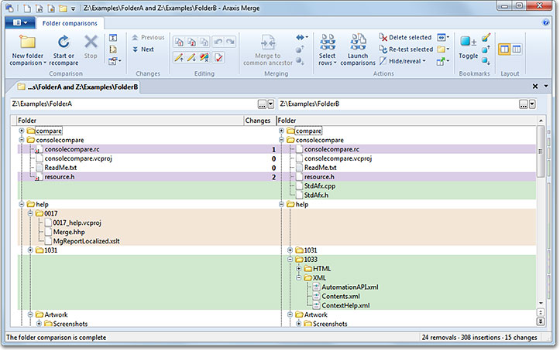

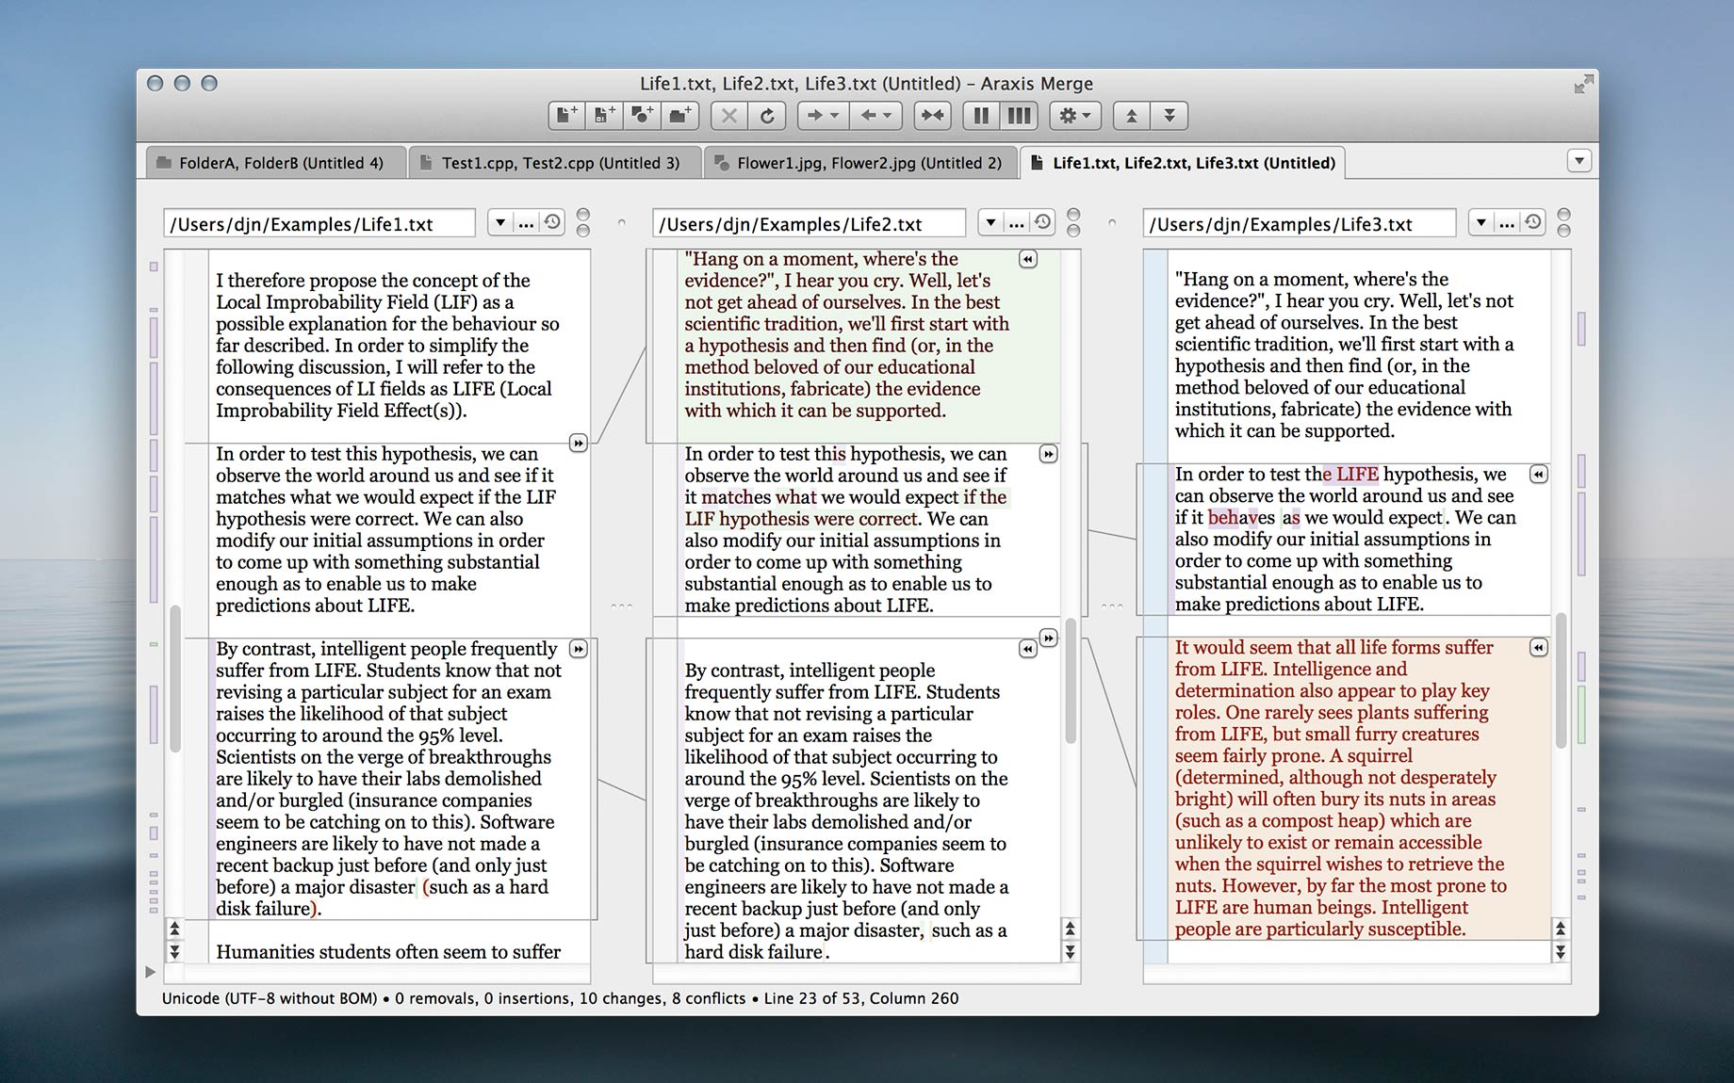

<http://www.araxis.com/merge/>

## BitBQ Changes

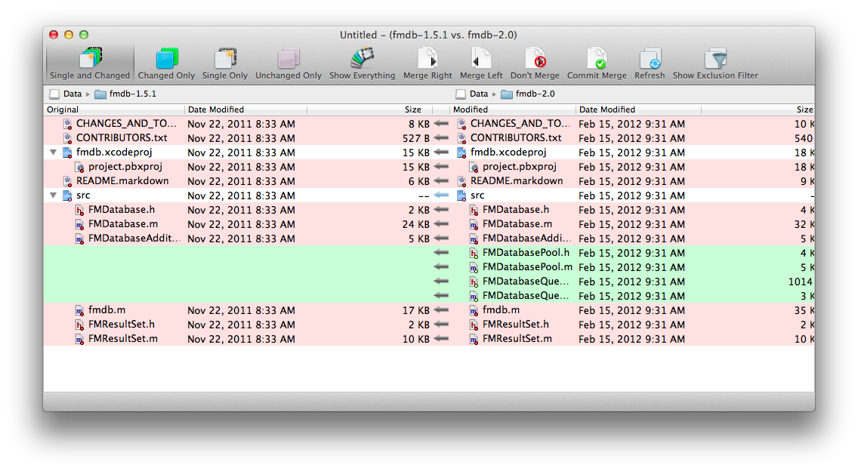

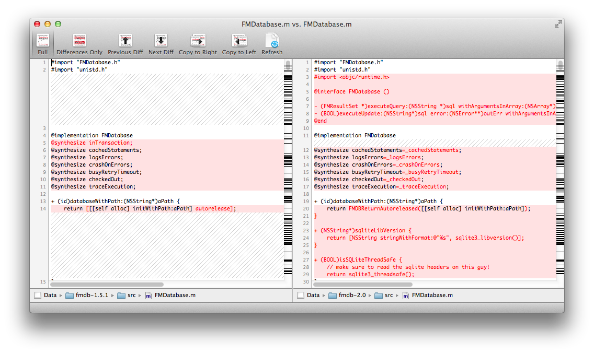

<http://bitbq.com/changes/images/TextDiff.png>

## Devart Code Compare

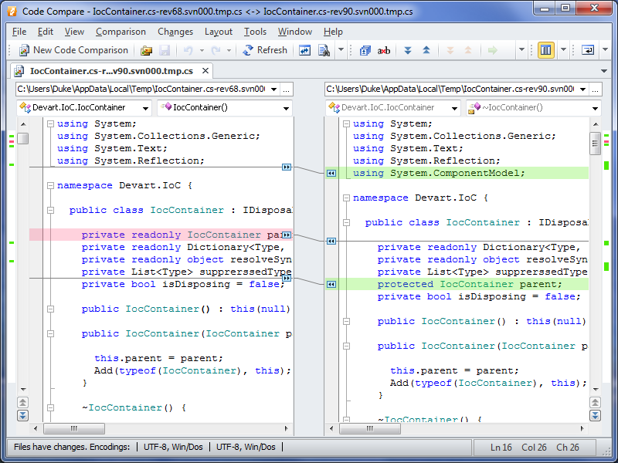

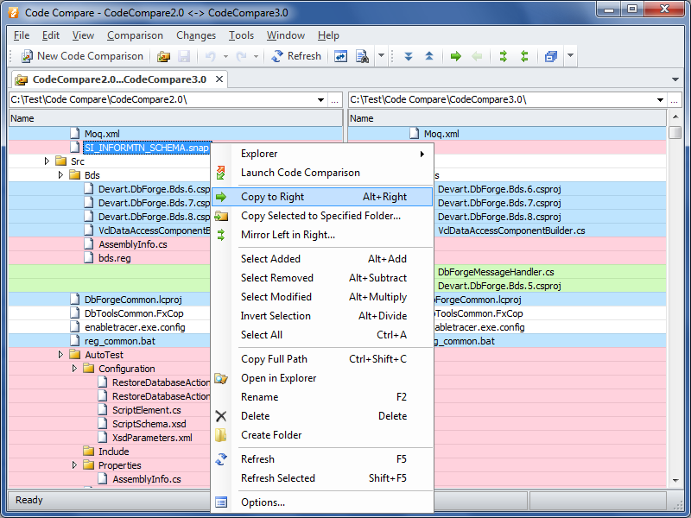

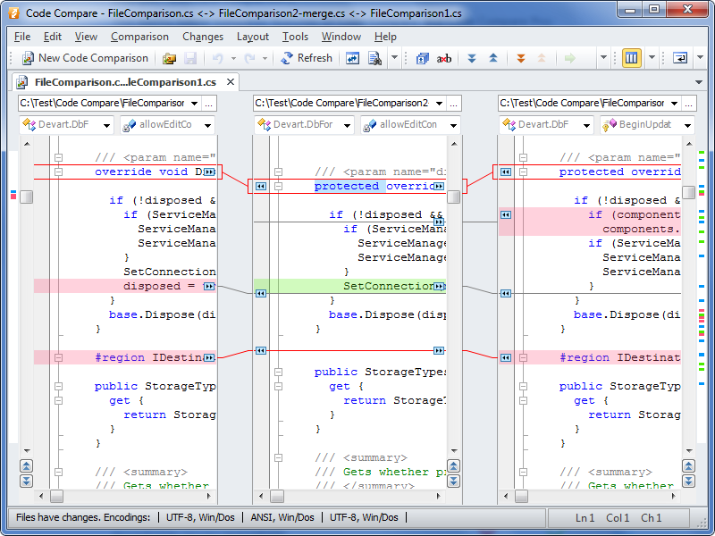

<http://www.devart.com/codecompare/>

## Compare++

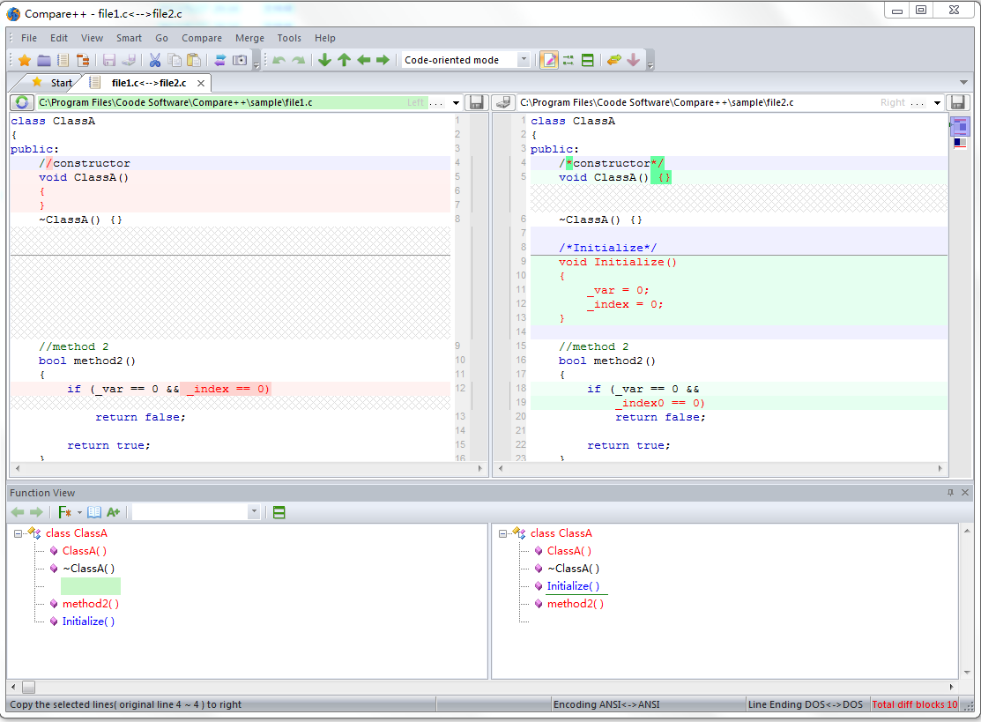

Able to compare using with programming language.

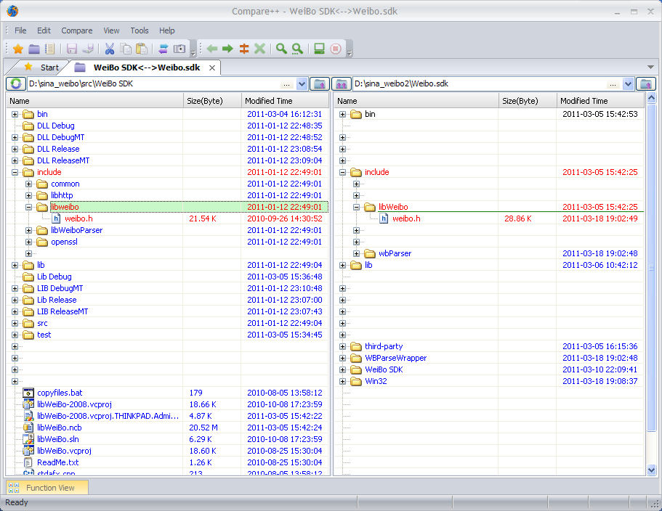

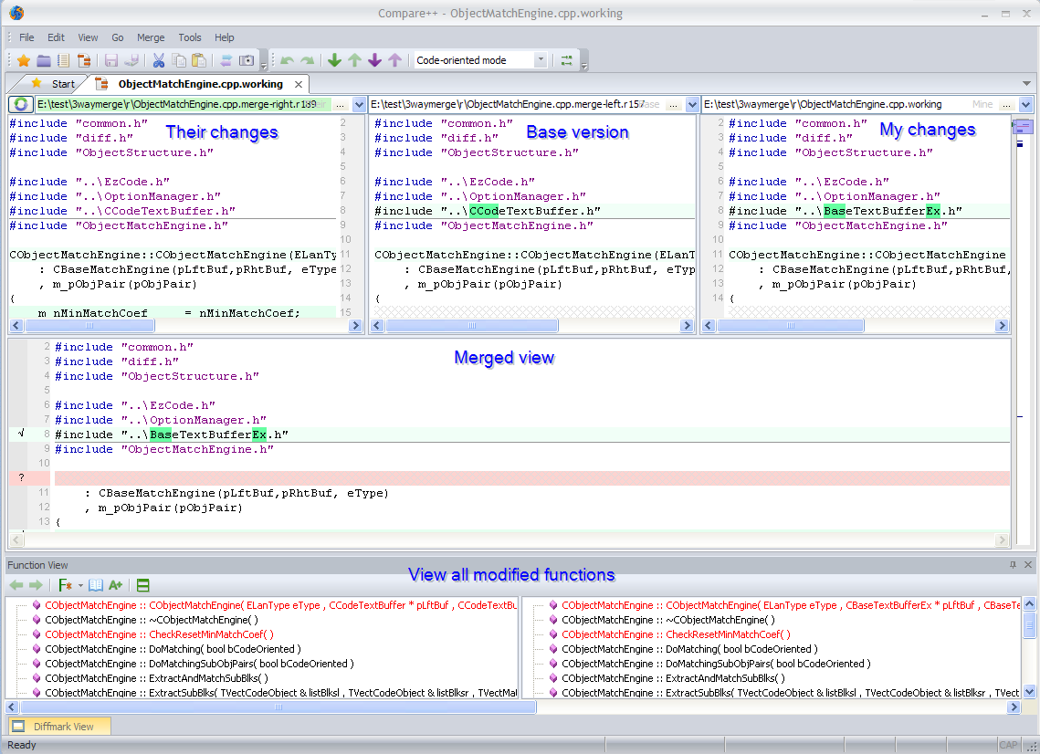

http://cmpp.coodesoft.com/

## Sourcegear DiffMerge

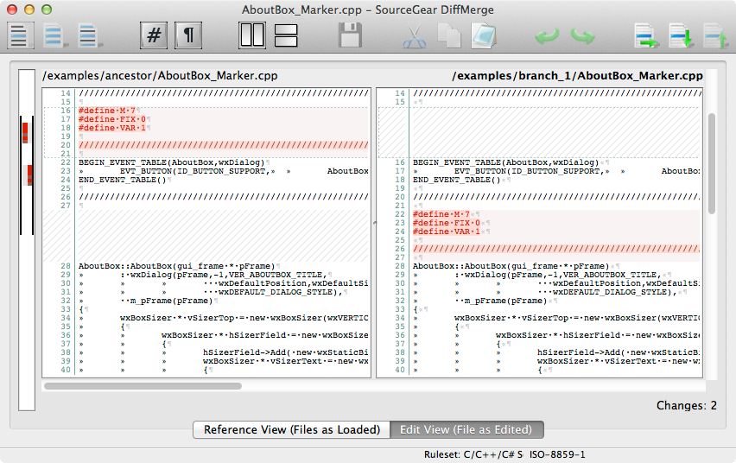

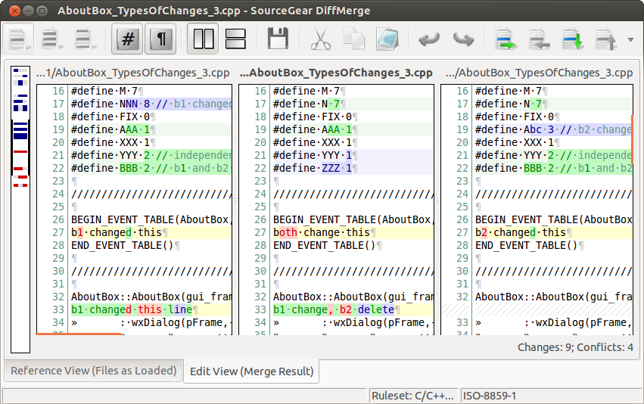

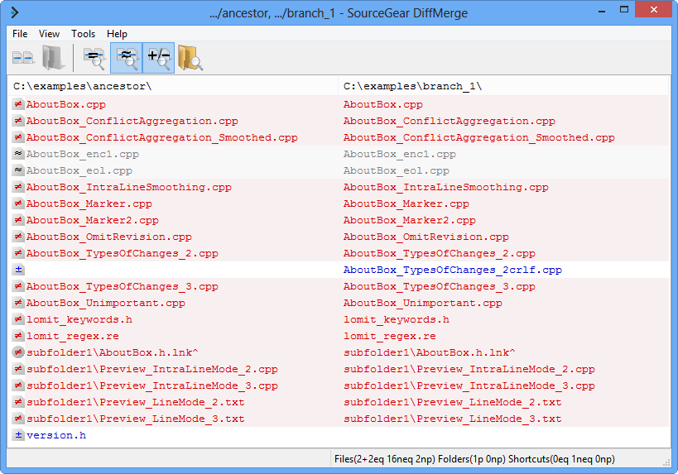

<http://sourcegear.com/diffmerge/index.html>

## Pretty Diff

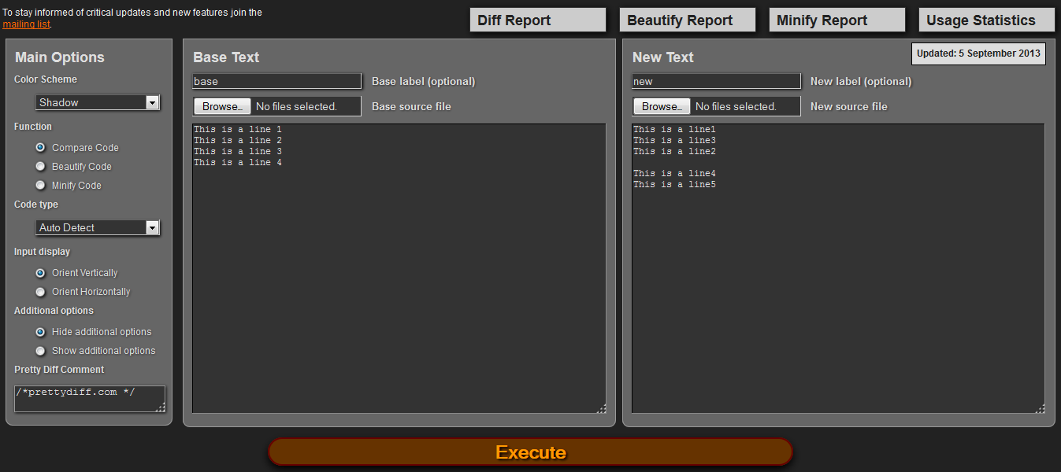

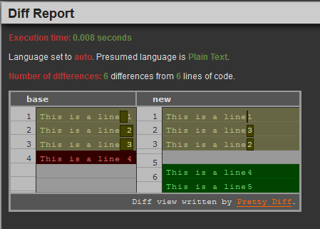

<http://prettydiff.com/>

## Kompare

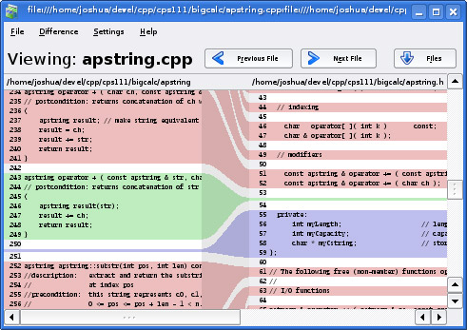

<http://www.caffeinated.me.uk/kompare/>

## Ultra Compare

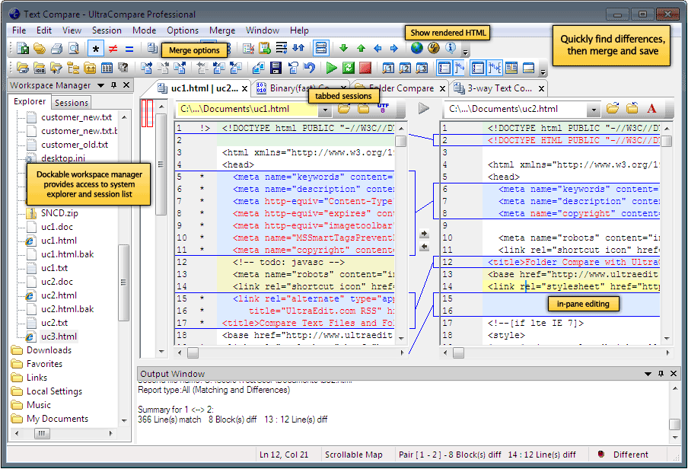

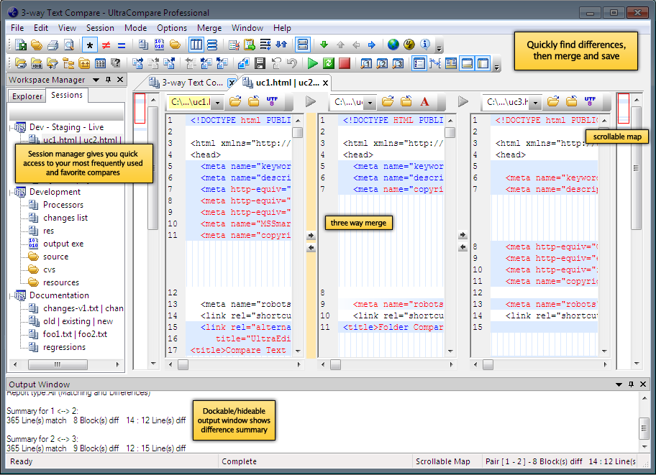

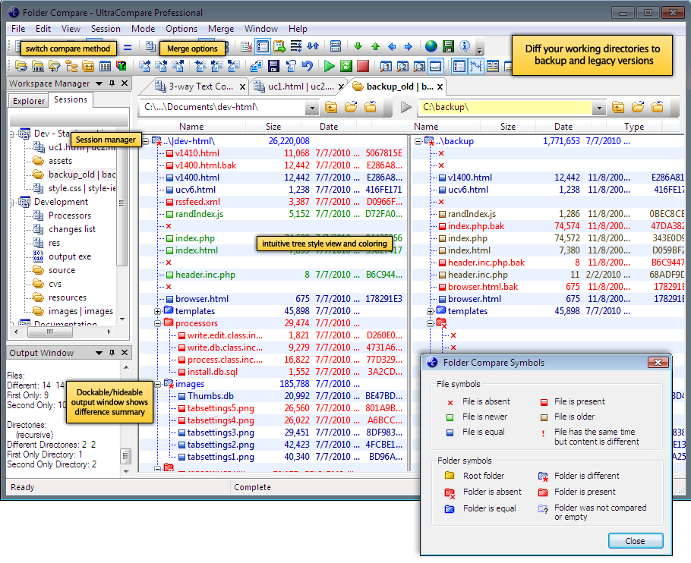

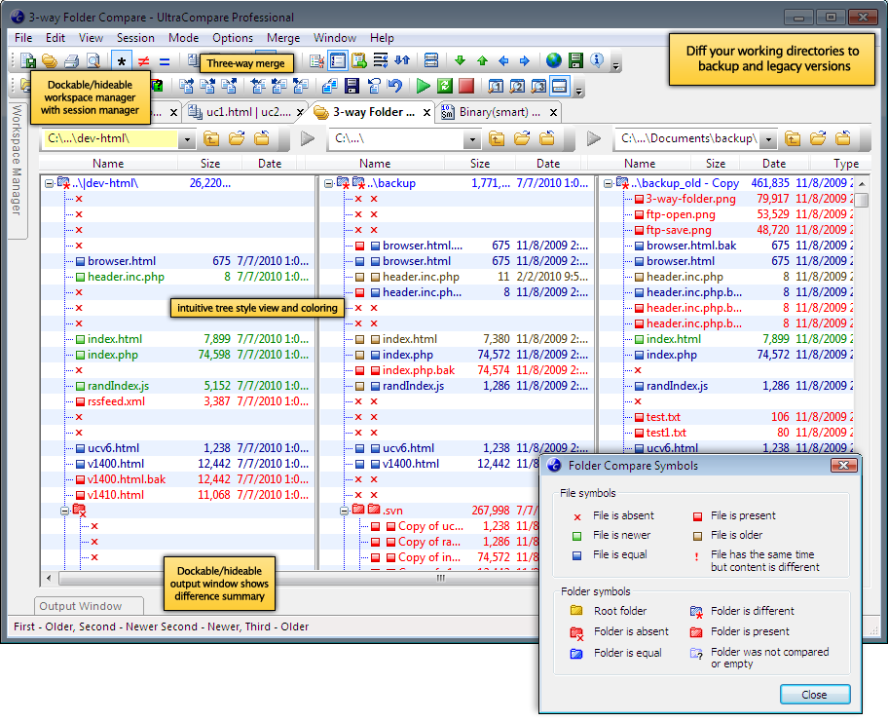

<http://www.ultraedit.com/products/ultracompare.html/>

## Code Difference Comparison Tool

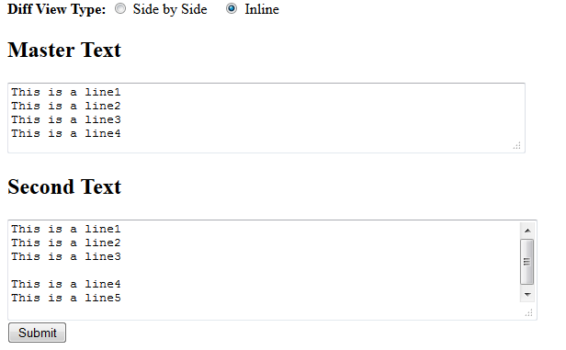

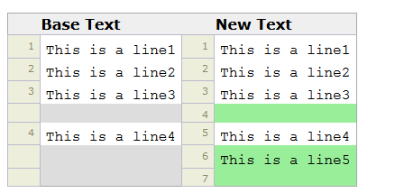

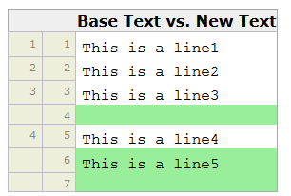

<http://www.tareeinternet.com/scripts/comparison-tool/>

## Diffuse

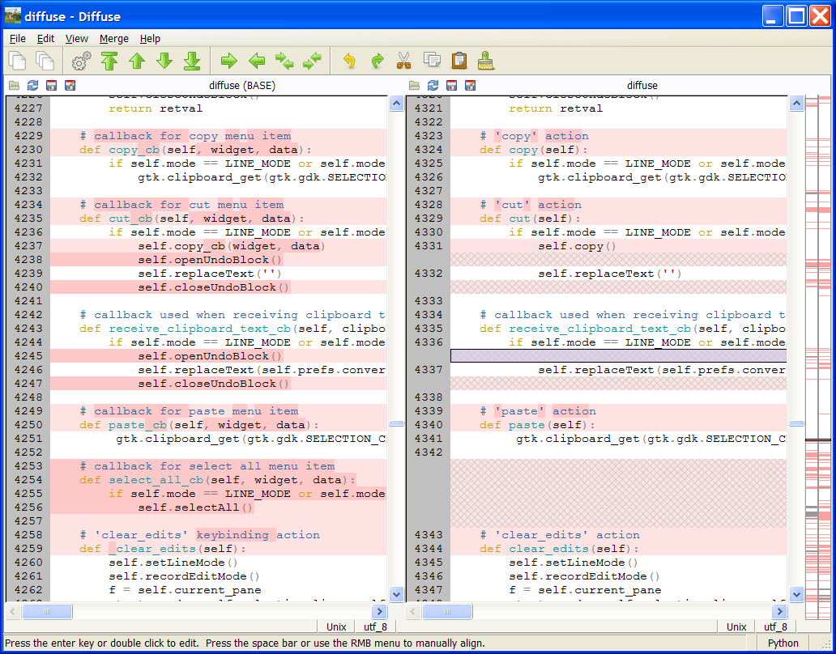

<http://diffuse.sourceforge.net/index.html>

## Compare&Merge

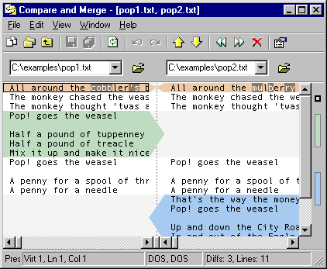

<http://www.compareandmerge.com/>

## Formula Software

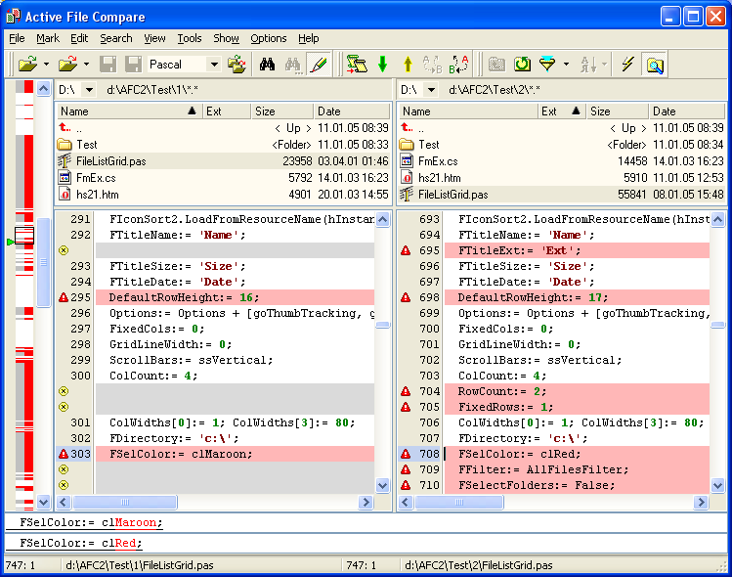

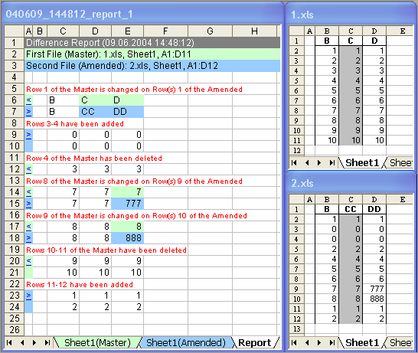

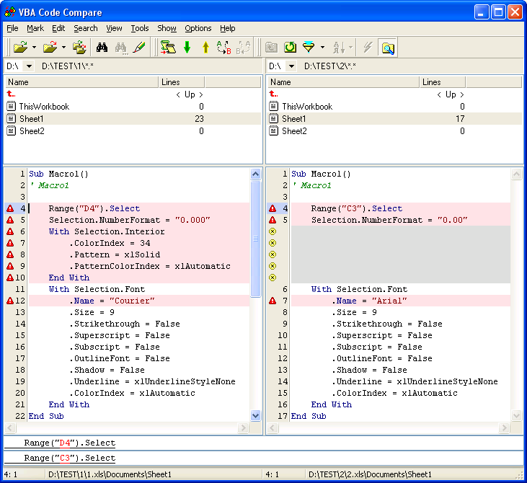

<http://www.formulasoft.com/index.html>

## ColorDiffs

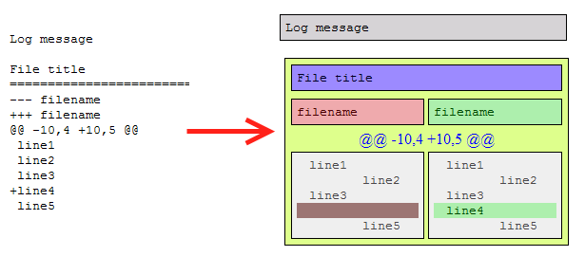

Not really a diff tool but a tool to improve the style of Subversion, CVS, Mercurial, etc diff messages.

<http://code.google.com/p/colorediffs/>

## Compare PDF

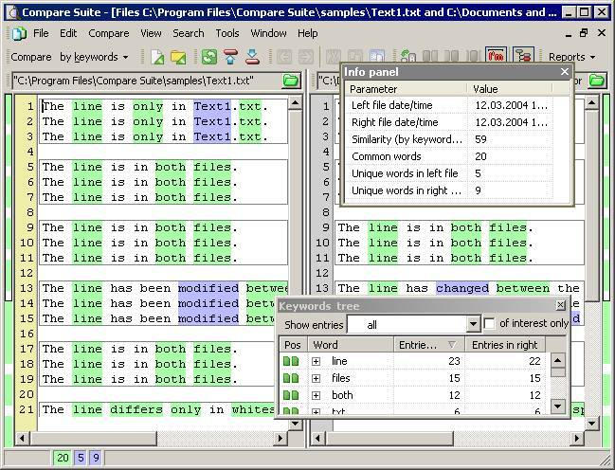

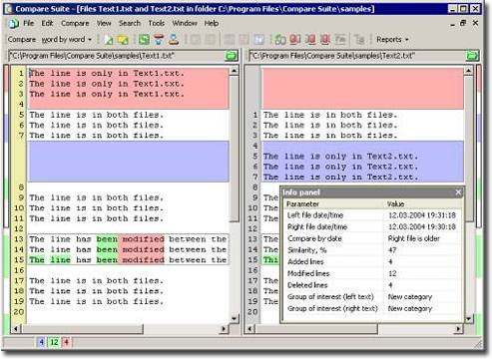

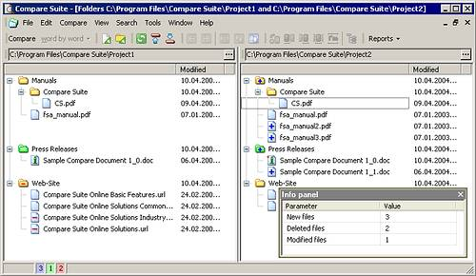

Seems either Bolide or Compare PDF used each other’s code…

<http://www.compare-pdf.com/>

DiffPDF

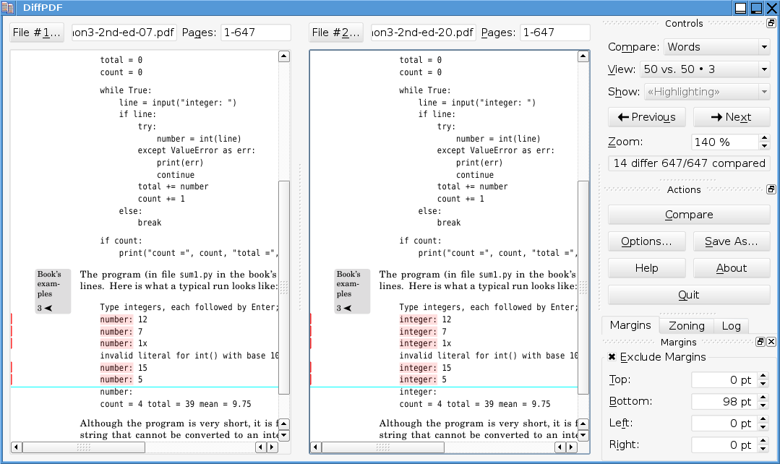

<http://www.qtrac.eu/diffpdf.html>

## Meld

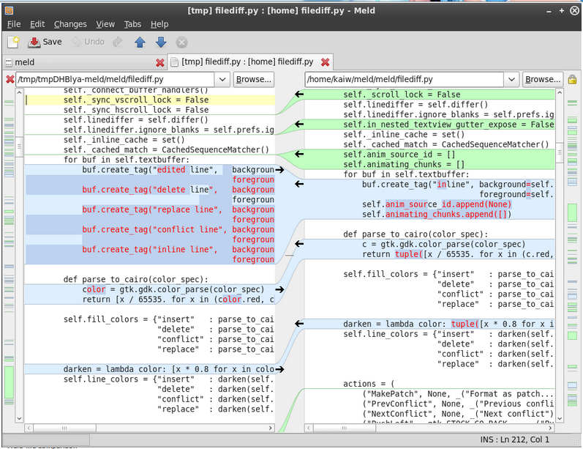

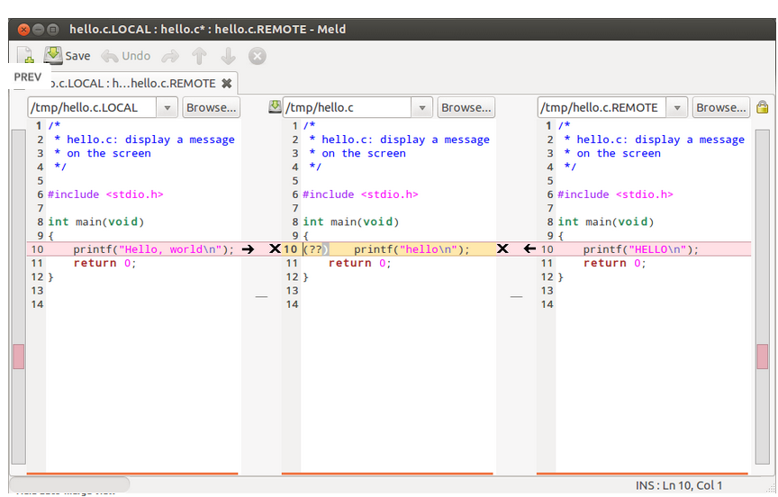

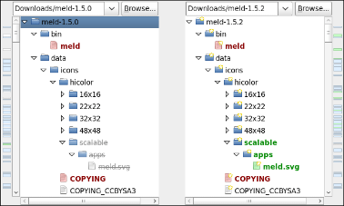

<http://meldmerge.org/>